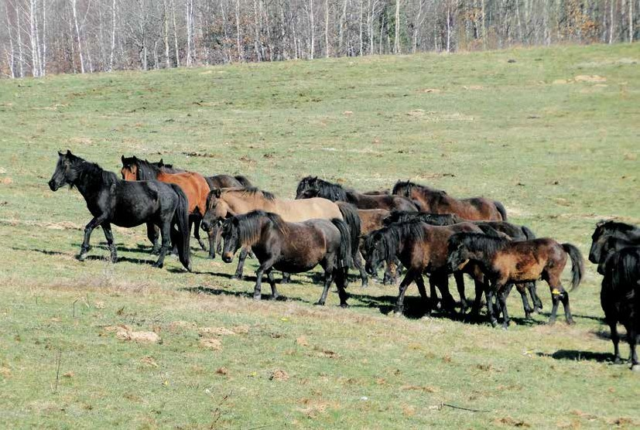

The Bosnian Mountain Horse carries the traits of
wild horses

Bosnian Mountain Horses grazing at Borike; characteristic hair colour of primitive horses without white marks (Photo: Marko Cotman )

The domestication and selection in horses differs from other domestic animals, because the basic purpose for which the horse was used had an additional positive impact on the results of natural selection. A cow able to produce 10,000 litres of milk would never appear in the natural selection process, and neither a sheep giving 7 kg of the best wool every year. While in natural selection, horses would become faster and faster and develop endurance and stamina. These same traits were also
a priority in the horse domestication process. A broad variety of sizes, shapes, movement and colours is characteristic for horses. Despite the significant differences in morphological traits they all belong to one single species, Equus caballus, with the same karyotype. The cross-breeding of various horse breeds gives healthy and fertile offspring.
Traits - characteristics found in Koniks are specific for primitive breeds, therefore Koniks are considered descendants of the extinct Tarpan (Photo: Matjaž Mesarič).

Horses almost died out around 7,000 years ago, when the horse population was limited to a small area of open steppes in current Ukraine and Central Asia. The ancestor of the domestic horse cannot be defined reliably, but probably the domestic horse developed from the wild horse living in the territory of Eurasia. Ostheological proof from the remains of numerous Eurasian wild horses display differences in the skull and metacarpal bones that
indicate only two existing subspecies of wild horses in the period following the last ice age; the western subspecies Equus ferus ferus and the eastern subspecies Equus ferus Przewalskii. The Tarpan died out in the 19th century, while the Przewalskii horse was saved at the brink of extinction and successfully re-populated in the wild. The probable ancestor of the domestic horse was the Tarpan that lived in the Eurasian steppes at the time of horse domestication. Newer DNA research shows that at least 77 different types (maternal lines) were present

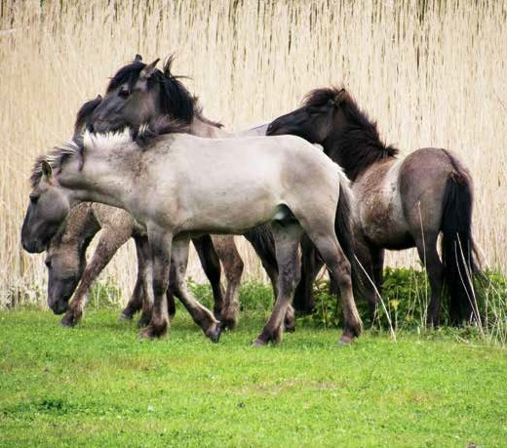in the creation of the domestic horse. The oldest known evidence of the occurrence of a domestic horse is the excavated settlement in southern Ukraine near Dereivka from the time 4,200-3,800 BC. From this area, horses probably spread to the East to
Siberia and Mongolia, and to Europe in the West. While other domestic animals were domesticated especially to provide food, the horse was domesticated primarily for driving and pulling, and also to provide food (meat and milk). The high intelligence and
adaptability of the wild ancestor horse were the key characteristics required for the success of the domestication process. Animals which successfully passed the domestication process were probably pre-adapted to domestication during the course of evolution. Some researchers think that the Tarpan had the required characteristics for successful domestication.
It was larger and able to run quickly and for a long time. Its specific digestive system allowed the horse to survive also with feed that was not sufficient for other domestic animals, so it was not a competition for cattle, goats or sheep.
Today’s primitive horse breeds are the Exmoor Pony, Gotland Pony, Fjord Horse, Garrano, Pottok, Asturcon, Hucul, Konik, Yakutsk Horse, Mongolian Horse and Sorraia Horse.

Koniks in the reservation in Netherlands are considered a primitive breed and successfully re-wilded (Photo: Matjaž Mesarič).

Anatomic research of horse ancestors
A general reduction in size on one hand and an increase in variability on the other hand are classical
indicators of domestication in domestic animals. Presumably the domestication process had little impact on the anatomic structure of the horse, as no ostheological differences were found between wild and domestic breeds
of horses. The evolutionary characteristics in horses were the reduction of toes on the limbs, an extension of the leg in such way that it stands on the toes, an increase in body size, a prolongation of the nuzzle and the development of a specialised tooth structure.

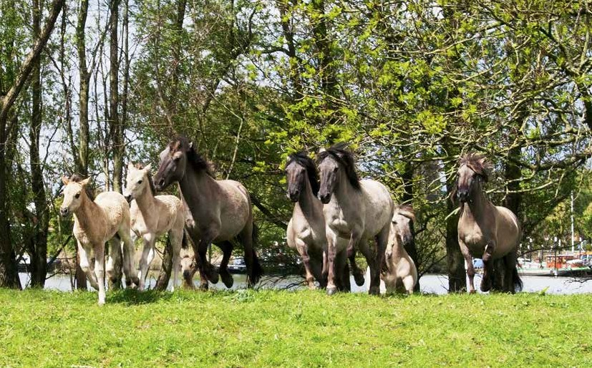

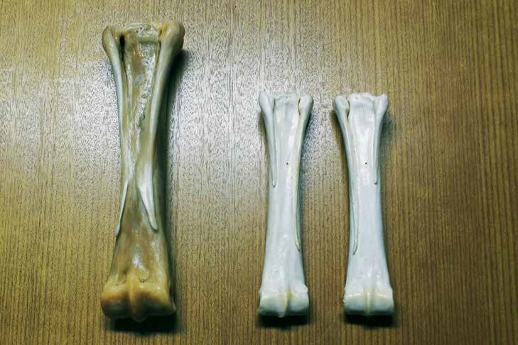

Cannon bones (left the cannon bone of an English Thoroughbred - the same length of the 2nd and 4th splint bones; on the right are the left and right front splint bones of a Konik; different lengths of the splint bones where the second is characteristically longer). (Photo: Anton Dolinšek)

Unlike other domestic animals (pigs, sheep and goats), the ancestor of the horse was extinct in the early 19th century. The Tarpan is probably an intermediate form between the horses from before the ice age, and the domestic horse, including the extinct species of Eastern European horses. On the basis of measurements of skulls in the Bosnian horse, Ogrizek found three forms that he divided into a Tarpan-type (a lighter skull with a slightly concave profile), a Przewalskii-type (a strong and heavy head with a slightly convex profile) and an island type (similar to the Tarpan, with typical pony characteristics). This study was the first to indicate a connection of horses in the type of Bosnian Mountain Horses with Tarpan-related wild horse horses and their descendants. The thesis was later recorded in history as the polyphyletic model of horse domestication. At the same time, Vetulani found similarities between the Tarpan and the Konik. Based on certain morphological and ethological differences, he assumed that the Konik was a subspecies of the Tarpan and called it the Forest Tarpan. In Bosnian Mountain Horses, Hrastnica was studying the primitive horse marks, such as zebra stripes, the occurrence of a protective colour with eel band, and the brightening of the hair in the winter.

Investigation of metacarpal / metatarsal bones in the Bosnian Mountain Horse (BMH) The efforts to preserve the uniqueness of primitive horses led to the introduction of the breeding program, in captivity specially adapted to their breeding and selection, and returning to the natural environment. In this context, it is particularly important to determine the criteria or markers on the basis of which a particular horse type is classified as primitive. One such breed is the Konik, a heavy and stout horse from Poland, which, according to experts, is the direct successor to the extinct Tarpan. Recent studies on Polish Koniks show the characteristic differences in the length of the stunted splint bones on their limbs. These differences were not found in the domestic horse (several horse breeds), where the length of the splint bones is equal in probably connected to the horse’s usability. The differences found on the splint bones could be an anatomic marker to distinguish primitive horse breeds and indirectly a characteristic tool to determine the horse domestication process.
Similar to the Konik, by its size and appearance the BMH belongs to the group of small horses. Many authors describe it as a horse of strong and robust construction, of excellent health and stamina, excellently adapted to a wide range of purposes, as a result mainly of natural as well as planned selection through the centuries. Over the millennia, the genotype of the BMH has preserved the diversity of native genes from ancestors. Despite the evidence about various primitive markings found in the BMH, it is still not known well-enough in the world as an important link to discover the differences between wild and domestic horses.
A research team from the Netherlands and Australia studied the Bosnian Mountain Horse at the Planido stud (ergela). This research team is currently researching the primitive traits that can be found in the Equus genus, such as the Przewalskii horse, donkey, zebra, Konik and the Yonaguni Pony (these group were researched until now). Until now, 10 breeds of the domestic horse (control group) and primitive horse breeds - among them the Bosnian Mountain Horse - were compared. The research is in its initial phase, but in the phenotype presentation and study of BMH, the scientists found differences in the splint bones similar to the Polish Koniks. In domestic horses, a symmetry of both splint bones can be observed. In Koniks, the second splint bone was longer than the fourth one. The results will be published soon as scientific research and will present the already presumed rarity of the BMH breed. Functional studies in horses shows that the third metacarpal bone supports and carries most of the weight; while the second metacarpal bone supports the inner, and the fourth metacarpal the side part of the wrist or foot. In addition, the second and fourth metacarpal support the third in torsion, as they counteract the bending of the wrist or foot. Probably, in the domestic horse the reduction of the outer and inner metacarpal bone and the prolongation of the middle one was important to increase the speed, while decreasing the stability and firmness of the limb. This at the same time reduced the energy consumption in movement due to the reduced weight of the limb. The increased stability of the limb and weight carrying was a major evolutionary advancement in the ancestor of the Bosnian mountain horse and Konik.

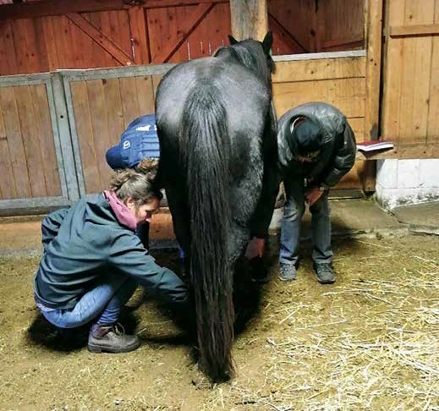As a critically endangered breed (fewer than 150 horses in the world at the moment) it is essential to preserve the BMH and with it also the primitive traits. This new and simple phenotype method can be a criterion for selection and the breeding programme in BMH and other primitive horse breeds.
Anatomic and genetic research of BMH established the extraordinary importance of this breed that can be considered one of the breeds preserving the traits of the ancestor. The importance of these existing primitive traits in BMH can be also a factor to further reduce the population. Often rarity and uniqueness are value too late, so we hope this will not apply to this horse which has served man so well in the past and which has passed the test of time.

The International Association of Bosnian Mountain Horse Breeders would like to thank Sharon May- Davis from the University of England in Australia; Zefanja Vermeulen from Equine Studies, Tanja de Bode from Freenature, Aldo Doveren from the Equine Veterinary Clinic and Christie Dreessen from the Equine Dentistry Veterinary Centre in the Netherlands.

Assist. prof. Dr Matjaž Mesarič, DVM
Expert Leader of the breeding program for the Bosnian Mountain Horse

Determining the difference in splint bone length on the front and hind legs through the skin in Bosnian Mountain Horses. (Photo: Anton Dolinšek)

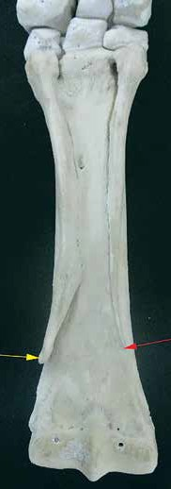

The transition from the ancestor with several toes to the horse with a single toe shows that the lower part of the limb can be an important point of comparison between primitive and domestic horses.
The horse has three metacarpal bones on the front and hind legs; out of these, only the third metacarpal/metatarsal bone is better developed and equipped with phalanxes. The second and fourth are stunted stick bones lying at the sides of the third metacarpal bone. Due to its cylindrical shape, the third main metacarpal/metatarsal bone is called also the cannon bone. The second and fourth phalanx in horses are heavily stunted and also called splint bones. The lower part of the splint bones is heavily stunted and button-shaped and can be felt through the skin in horses. The position of these buttons allows to simply determine the relative length of the splint bones on the front and back limbs.

